**Get Method: GetProducts**

Functionality: is to get all the products

url

response message

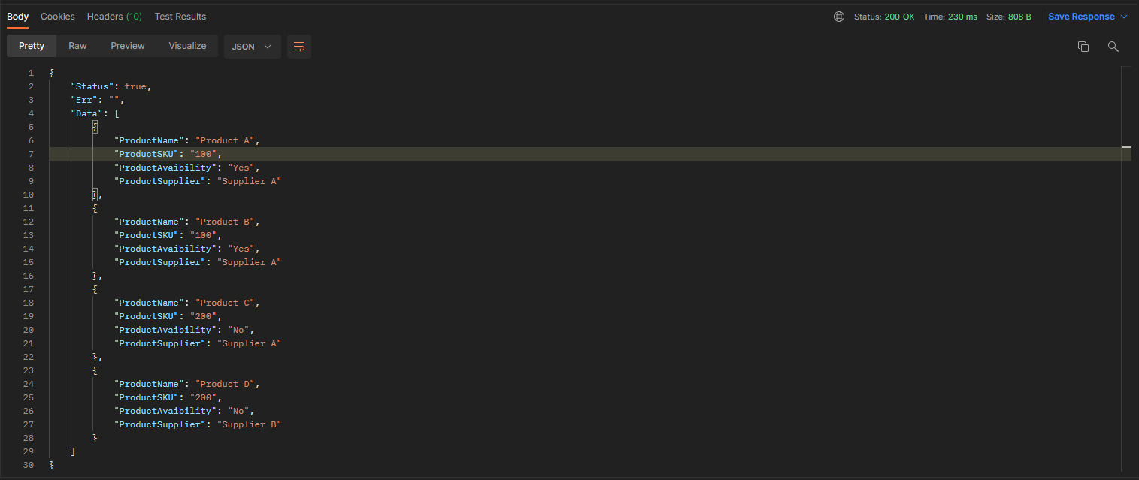

**Post Method: CreateProductSupplier**

Functionality: is to create supplier

url



request message

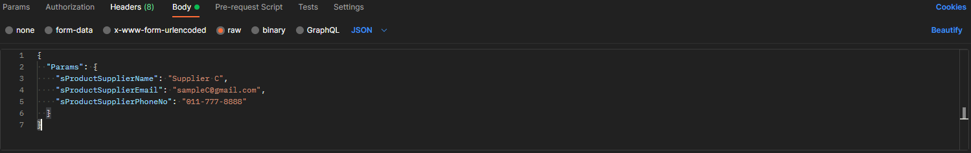

response message

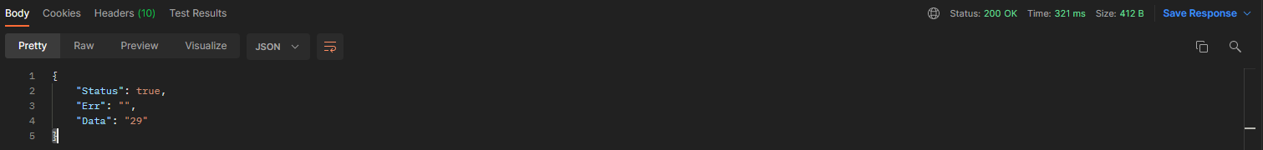

**Post Method: CreateProductSupplier**

Functionality: is to create product

url



request message

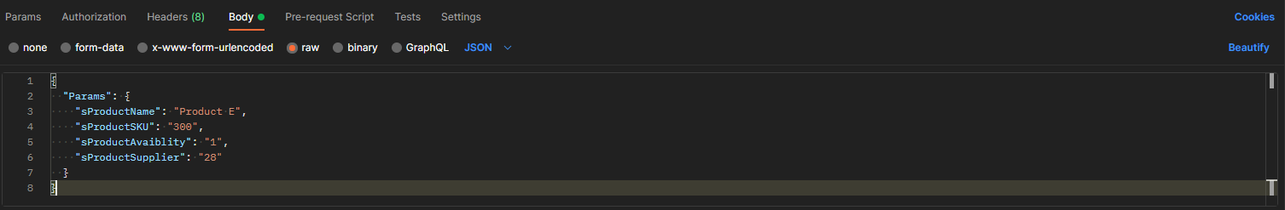

response message

